Module 7 – Assignment

Problem 5: For each consistency error in Figure 1, you should identify the consistency rule violated and suggest possible resolutions of the error. The ERD has generic names to help will concentrate on finding diagram errors rather than focusing on the meaning of the diagram.

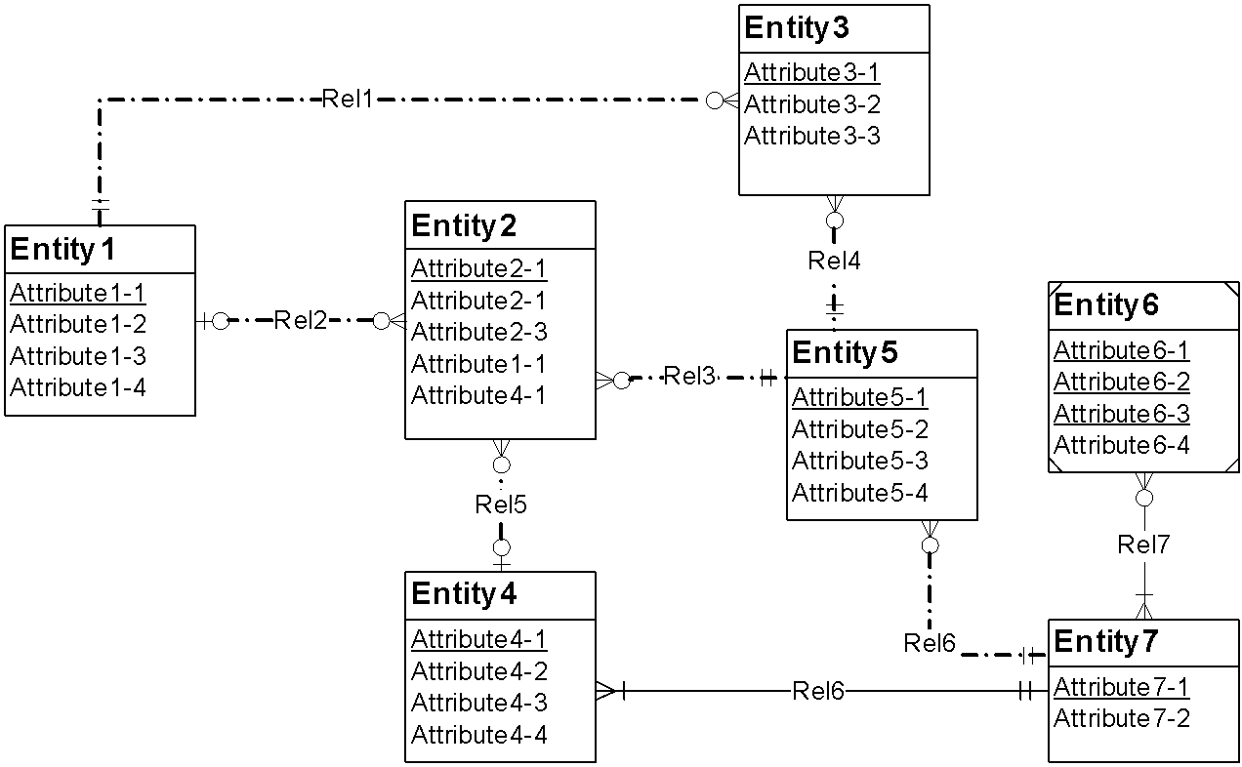

* Redundant Foreign Key Rule: Entity 2 has two foreign keys listed as well as the relationship lines. Remove foreign keys 1-1 and 4-1 from Entity 2.
* Identifying Relationship Rule: Rel6 is an identifying relationship with no weak entities. Change to non-identifying relationship.
* Identification Dependency Cardinality Rule: Entity 6 has wrong cardinality to its identifying parent (Entity 7). If, in fact Entity 6 is weak, change one-or-more (|<-) to one-and-only-one (||-) from Entity 6 to Entity 7. If Entity 6 is not correctly weak then change it to strong with a non-identifying relationship to Entity 7.